Worksheet 1

Learning Intention | Justify why we should care about climate change.
Why | Humanity has never faced a challenge like this and the time to do something about it is now.
Success Criteria | You can explain why understanding climate change is important in 25 words or less.
Activities | Watching videos, listening, talking, reading and writing.

Activity 1

Watch this:

https://www.youtube.com/watch?time_continue=191&v=DJuRjy9k7GA

What is the message she wants to give her child?
What does the author of the poem state the negative impacts of climate change to be?

Activity 2

Climate migrants: Catastrophic Science, UNSWTV , 15 Jun 2015
https://www.youtube.com/watch?v=pPWvGNeFPEs

Which university produced this video?
How many people could be forced from their homes from changing climate in the decades ahead (0:32)?
Is this number larger or smaller than the current population of Australia? Australia’s population clock can be found at http://www.abs.gov.au/ausstats/abs@.nsf/0/1647509ef7e25faaca2568a900154b63

Outline what happened in Bolivia (1:37)?
Outline what has happened in Bangladesh (1:54)? How many people have had to move?
What happened on Hathifushi Island in the Maldives (2:07)? How many years later did they still not have proper houses (2:26)?
Do both clips say that rising sea levels will have a positive or negative impact on people’s lives?

ONE MAJOR REASON WE SHOULD CARE ABOUT CLIMATE CHANGE IS BECAUSE IT IS ALREADY FORCING SOME OF THE POOREST PEOPLE IN THE WORLD TO MIGRATE.

Activity 3

Watch this:
Witnessing rescue efforts for Mediterranean migrants, Al Jazeera English, 3 June 2015
https://www.youtube.com/watch?v=9Gd4q7_YIn4

In your opinion, on a scale of 1-10 how bad was this situation?
Could the migrants in the video swim?
If YOU could not swim, what would be so bad that YOU would get on an unreliable boat?
Why do you think they got on those boats?

THIS VIDEO SHOWS ONE EXAMPLE WHAT IT LOOKS LIKE WHEN THE MOST POWERLESS PEOPLE IN THE WORLD ARE FORCED TO MIGRATE. OVER THE NEXT CENTURY CLIMATE CHANGE IS GOING TO MAKE THIS MORE COMMON.

Activity 4

Read this:

“In 2015, the number of people applying for asylum in the EU (Europe) peaked at 1.26 million to trigger the current migration crisis, while over 2,257 people are thought to have lost their lives in the Mediterranean in the first six months of 2017 alone (as of 28 June 2017). In 2016 5,022 lives were estimated to be lost in the Mediterranean and in 2015 3,771.”
(http://www.europarl.europa.eu/news/en/headlines/society/20170629STO78630/eu-migrant-crisis-facts-and-figures)

What is the population of your school?
How many times the population of your school drowned in those years?
Do you think it is fair that the poorest people in the world will have to migrate in these conditions?

Activity 5

Read these extracts from the IPCC 5th Assessment report, summary for policymakers, Page 16 and respond to the written tasks:

· “Climate change is projected to increase displacement of people (medium evidence, high agreement).

Define “displacement”.
Rewrite this sentence in your own words.

· “Populations that lack the resources for planned migration experience higher exposure to extreme weather events, particularly in developing countries with low income.”

Outline a weather event that you think might force people to move, whether they are ready to or not.

· Climate change can indirectly increase risks of violent conflicts by amplifying well-documented drivers of these conflicts such as poverty and economic shocks (medium confidence).”

An “economic shock” is a situation where a person or community suddenly has access to less wealth than previously. Give one why you think a sudden loss of wealth could lead to violence.

Read this extract from the IPCC 5th Assessment report, summary for policymakers, Page 13 and respond to the written tasks:

· “Climate change will amplify existing risks and create new risks for natural and human systems.”

Use a dictionary to define “amplify”.
Rewrite this sentence using your own words.

· “Risks are unevenly distributed and are generally greater for disadvantaged people and communities in countries at all levels of development.”

Outline why you think this is.

Activity 6

Watch this:
Tim Flannery: Reef Reality Check, The Climate Council, 8 June 2016
https://www.youtube.com/watch?v=Ylu5YFExjcc

Do you want to visit the Great Barrier Reef?
How many people rely on the Great Barrier Reef for employment (2:44)?
How many people is this compared to the population of Wagga?
How would you feel if you, your parent/s or carers had their job threatened by climate change?

Activity 7

Watch this:
Climate change and the Riverina, Simple Climate Action, April 12 2018
https://www.youtube.com/watch?v=C8SZEUsXAXI

Outline which of these you think is the worst impact? You may have to watch the video through again to decide.

Activity 8

As you read the following list of negative impacts of climate change from:

https://www.scientificamerican.com/article/state-of-the-science-beyond-the-worst-climate-change-case/

circle or highlight what you believe to be the worst impacts. This passage talks about global impacts, not just local impacts.
“Warming Temperatures—Continued global warming is virtually certain (or more than 99 percent likely to occur) at this point, leading to both good and bad impacts. On the positive side, fewer people will die from freezing temperatures and agricultural yield will increase in colder areas. The negatives include reduced crop production in the tropics and subtropics, increased insect outbreaks, diminished water supply caused by dwindling snowpack, and increasingly poor air quality in cities.
Heat Waves—Scientists are more than 90 percent certain that episodes of extreme heat will increase worldwide, leading to increased danger of wildfires, human deaths and water quality issues such as algal blooms.
Heavy Rains—Scientific estimates suggest that extreme precipitation events—from downpours to whiteouts—are more than 90 percent likely to become more common, resulting in diminished water quality and increased flooding, crop damage, soil erosion and disease risk.
Drought—Scientists estimate that there is a more than 66 percent chance that droughts will become more frequent and widespread, making water scarcer, upping the risk of starvation through failed crops and further increasing the risk of wildfires.

Stronger Storms—Warming ocean waters will likely increase the power of tropical cyclones (variously known as hurricanes and typhoons), raising the risk of human death, injury and disease as well as destroying coral reefs and property.
Biodiversity—As many as a third of the species known to science may be at risk of extinction if average temperatures rise by more than 1.5 degrees Celsius.
Sea Level Rise—The level of the world's oceans will rise, likely inundating low-lying land, turning freshwater brackish and potentially triggering widespread migration of human populations from affected areas.
"As temperatures rise, thermal expansion will lead to sea-level rise, independent of melting ice," says chemical engineer Lenny Bernstein, another lead author of the recent IPCC report. "The indications are that this factor alone could cause serious problems [and] ice-sheet melting would greatly accelerate [it]."
Such ice-sheet melting, which the IPCC explicitly did not include in its predictions of sea-level rise, has already been observed and may be speeding up, according to recent research that determined that the melting of Greenland's ice cap has accelerated to six times the average flow of the Colorado River. Research has also shown that the world has consistently emitted greenhouse gases at the highest projected levels examined and sea-level rise has also outpaced projections from the IPCC's last assessment in 2001. "We are above the high scenario now," says climatologist Stephen Schneider of Stanford University, an IPCC lead author. "This is not a safe world."

Activity 9

Watch this video
https://www.youtube.com/watch?v=c4fmXcwJPCg

Identify the type of natural disaster that has caused this emergency

According to the article above, is climate change causing more flooding or less flooding around the world?

Activity 10

Watch this video: Climate change may have boosted Haiyan - Al Jazeera English, 13 Nov 2013
https://www.youtube.com/watch?v=95Q9Pe3zgEo

What is the name of the strongest storm ever recorded?

How fast were the winds recorded in this cyclone?

Could climate change be making these winds stronger or weaker?

Activity 11

In your opinion on a scale of 0-10, how bad is climate change?
● 0= not bad at all
● 5= kind of bad
● 10= as bad as it gets
What made you choose your value above?
In 25 words or less, why should we learn about climate change?

Worksheet 2

Learning Intention: | Outline the 5 main areas of climate.
Why: | So we can understand “climate change”.
Success Criteria: | I can successfully distinguish between weather and climate.
Activities | Reading, writing, weather observations, using maps.

Activity 1

In the boxes below, write down the dictionary definitions of the words weather and
climate.

Weather
Climate

In the space below, contrast (state how they are different) the terms weather and
climate. Make sure you include how quickly each can change.

Use this link http://www.bom.gov.au/nsw/wagga/climate.shtml and write down three key facts about Wagga’s climate.

1
2
3

Talk to the people in your group and guess the main things we measure when looking at
weather and climate. It is OK to leave some blank if you are not sure what to write. The first one is done for you.

1 | Temperature
2
3
4
5

Activity 2

Read the paragraph under the heading “What Is the Difference Between Weather and
Climate?” on this webpage.

https://www.nasa.gov/audience/forstudents/5-8/features/nasa-knows/what-is-climate-change-58.html

List the 5things that make up climate from this paragraph.

1 | T____________
2 | C____________ Cover
3 | P____________
4 | H____________
5 | W____________

Activity 3

Head outside and estimate each the readings for each of the above
measurements for the day.

1 | Temp= degrees Celsius
2 | Rainfall in last hour = mm
3 | Wind = kmph
4 | Humidity= %
5 | Cloud cover= %

Activity 4

Take five mins only and use this website https://earth.nullschool.net/ to estimate the weather readings at your current location. By clicking on your approximate location on the map, the page will give you information for the current weather in the bottom left hand corner. Change between different types of weather information by clicking on the “earth” link in the bottom left hand corner also. Again, don’t worry if you have to leave some blank.

1 | Wind= kmph
2 | Temp= degrees Celsius
3 | Rainfall= mm in last 3 hours
4 | Humidity= %

The reason some of your readings may have differed is that the location you chose on the
Nullschool website may not be totally accurate. But that is fine, just move on to activity 5.

Activity 5

Check to
see what the actual measurements are by using:

http://www.weatherzone.com.au/nsw/riverina/wagga-wagga
or
http://www.bom.gov.au/products/IDN60801/IDN60801.94910.shtml

List them below

1
2
3
4
5

Activity 6

In the box below, describe the climate in some of your favourite
potential tourist destinations. Use Google to help you find stats.

List of reliable websites for Geography information

1. “.gov”
2. The Scientific American
3. The Conversation
4. National Geographic
5. BBC
6. Australian ABC
7. Wikipedia - but must cross check with another listed website
8. Australian Geographic
9. “.edu”
10. TED ed
11. Geogspace
12. Skwirk
13. Scootle
14. NASA
15. Time.com

Worksheet 3

Learning Intention | Explain the process of climate change.
Why | Climate change is making big changes around our world.
Success Criteria | Make accurate flow chart and write explanation in paragraph form.
Activities | Reading, creating group flow chart.

Activity 1

Read this page

https://www.natgeokids.com/au/discover/geography/general-geography/what-is-climate-change/#!/register

Activity 2

Use your flow chart materials to create the correct flow chart in your working group. Check this off with your teacher before attempting activity 3.

Activity 3

Explain the process of climate change in the box below.

Boxes for flow chart below

World population is increasing.
This is creating more demand for...

Burning oil and gas to create electricity. This is creating more greenhouse gas emissions.

A higher global population of cows.
This will lead to more methane (a greenhouse gas) in the atmosphere.

Resources from forests. Trees are able to convert Carbon Dioxide back to Oxygen, decreasing the amount of greenhouse gases in the atmosphere.

But if we chop the trees down...
This will increase the amount of greenhouse gases in the atmosphere, which act like a blanket, trapping heat and warming up the atmosphere.

The atmosphere has warmed by approximately 1 degree Celsius over the last century and likely to go higher as this century progresses.
Rising sea levels. Threatening the nesting beaches of sea turtles.

Changing seasons.

Warmer temperatures could mean that more female turtles are born compared to male turtles.

Farming becomes more difficult, which could lead to an increase in the use of chemicals that destroy soils.

Shrinking areas of sea ice.

Therefore less habitat for polar bears and certain seal species.

Worksheet 4

Learning Intention | Expand our knowledge of climate change.
Why | There are many more effects than what we have learned about so far.
Success Criteria | You have supported the explanation from the last lesson with further details from resources included in this document.
Activities | Reading, writing, talking.

Activity 1

Fill in the table below using the information from the flow chart last lesson. One sentence per number please.
Causes of climate change | 1  2  3  4
Effect on the atmosphere | 1  2
Effects of warming atmosphere on the other three spheres | 1  2  3

Activity 2

Look at this link:
https://www.nationalgeographic.com/environment/climate-change/
Scroll across the “Seven things you need to know about climate change”. Use statistics from each of these seven areas to add to the box below. Some examples have been done for you already. Include some stats from the graphs.

● More than 90% of climate scientists agree that our current climate change is mainly caused by humans.
● Sea level could rise by 90cm (three feet by the year 2100).
● 2017 average global surface temperature was 1.69 degrees Celsius warmer than the 20th century average.
● We have increased the amount of Carbon Dioxide in the atmosphere by half since the 1960’s.

Activity 3

In groups, explain the process of climate change in essay format by replacing the (fill this in) sections with your own knowledge. Hint: Use statistics you have included in the last two activities in this worksheet in order to complete this.

Intro
Climate change refers to changing patterns of weather. At this point in time Earth’s climate is changing due to (fill this in). Over nine out of ten climate scientists believe (fill this in). This essay will explain (fill this in).

Body paragraph one
Point | Humans are causing climate change through various activities.
Explain/  Example | (fill this in)
Link | Therefore our current changes in climate are due to (fill this in).

Body paragraph two
Point | These human activities are having an effect on our atmosphere.
Explain/  Example | (fill this in)
Link | Due to this our atmosphere is (fill this in).

Body paragraph three
Point | Changes in atmospheric temperature have an impact in humans. Heat waves can be devastating.
Explain/  Example | (fill this in)
Link | Atmospheric temperature has a big impact on humans.

Body paragraph four
Point | The changes in our atmosphere have a flow on effect into other areas of the Earth.
Explain/  Example | The amount of ice around the world is (fill this in)
Link | (fill this in)

Body paragraph five
Point | The biosphere is also impacted as a flow on effect from changes in climate.
Explain/  Example | Bramble Cay Melomys (fill this in)
Link | (fill this in)

Conclusion
Climate change can be viewed as a series of steps in a process. These include (fill this in)

Worksheet 5
Learning Intention | Create visual aids in order to back up our essay ideas.
Why | Visual aids can support meaning being given to the reader.
Success Criteria | Can make a flowchart to represent the ideas in each of the paragraphs from the essay created in the last lesson.
Activities | Drawing flow charts and a sketch map.

Activity 1

COPY and paste the essay you attempted in the last lesson in the box below.

Activity 2

Use your paper workbooks OR the drawing function in the {Insert - Drawing… menu} to create a flow-chart explaining each of the ideas in each body paragraph.

For example

Body paragraph one

Body paragraph two

Body paragraph three

Body paragraph four

Body paragraph five

Activity 3

Take at least half a page in your workbook to create a sketch map to illustrate the location of the former colony of Bramble Cay Melomys. Remember to include

B order (around the edge of the map)
O rientation (which way the north pole is)
L egend (key)
T itle (what is the point of the map_
S cale (how big an area does it show)
S ource (how do you know)

Use the satellite photo below to help you

Peer feedback

Activity 1

Read the essay that one of your peers has written.

Activity 2

Fill in the blank sections below:
● Did you like the essay? Why or why not?
● Did the essay explain the process of climate change using different steps? Were any missing?
● Did the essay use statistics? How many? Were there enough? Why or why not?
● Did the essay use geographical terminology? Did it use enough? Why or why not?
● Did the essay give good examples to back up ideas? Why/why not?
Highlight the sections of the writing that you liked in yellow. For each section leave a 1-2 sentence comment which states why you liked them. A section could be as short as one word or as long as a paragraph.
Highlight the sections that did not make sense to you in green. For each of these sections, leave a 1-2 sentence comment on what did not make sense and how you think they could be improved. A section could be as short as one word or as long as a paragraph.

Activity 3:
● Read each of the grade descriptors first.
● Think about which grade the essay you read should get.
● Fill in one of the boxes in the “The essay fits into…” column. You will need to state why you think the essay fits into this category.
Grade | Grade descriptor | The essay fits into...
Grade A | The student has an extensive knowledge and understanding of the content and can readily apply this knowledge. In addition, the student has achieved a very high level of competence in the processes and skills and can apply these skills to new situations.
Grade B | The student has a thorough knowledge and understanding of the content and a high level of competence in the processes and skills. In addition, the student is able to apply this knowledge and these skills to most situations.
Grade C | The student has a sound knowledge and understanding of the main areas of content and has achieved an adequate level of competence in the processes and skills.
Grade D | The student has a basic knowledge and understanding of the content and has achieved a limited level of competence in the processes and skills.
Grade E | The student has an elementary knowledge and understanding in few areas of the content and has achieved very limited competence in some of the processes and skills.

Activity 4
Give your feedback to the student that you borrowed the essay from. Read the feedback they gave you.

Activity 5

Assign yourself a grade based on the above descriptors. State why you think you achieved this grade in the box below.

Worksheet 6

Learning Intention | Practice labelling maps with scientific information.
Why | Maps are often used in the media and are an easy way of identifying where things occur.
Success Criteria | Each of facts below are correctly labelled on a blank map using the BOLTSS convention.
Activities | Reading and labelling a map.

Activity 1

Read the following dot points. They list impacts we are already seeing in Australia. This information has come from the best source of information we have on this issue, The Intergovernmental Panel on Climate Change.

● Significant decline in late-season snow depth at 3 of 4 alpine sites in Australia.
● Intensification of hydrological drought due to regional warming in southeast Australia.
● Reduced inflow in river systems in south western Australia.
● Expansion of some wetlands and contraction of adjacent woodlands in southeast Australia.
● Expansion of monsoon rainforest at expense of savannah and grasslands in northern Australia.
● Southward shifts in the distribution of marine species near Australia.
● Increased coral bleaching in Great Barrier Reef and western Australian reefs.
● Changed coral disease patterns at Great Barrier Reef.

(http://www.ipcc.ch/pdf/assessment-report/ar5/wg2/ar5_wgII_spm_en.pdf ,Page 31) The hyperlink is just for reference only, you do not need to click on it. It lists locations and some of the changes we are already seeing due to climate change in Australia

Activity 2

Attempt to circle these regions in Australia on a blank map. I have given you some key words to use in a Google search in yellow. You may use the internet to search for your own information. You do not need to be specific when you circle the areas, an estimate is fine.

● Significant decline in late-season snow depth at 3 of 4 alpine sites in Australia. Google search term: “australian alps”
● Intensification of hydrological drought due to regional warming in southeast Australia.
● Reduced inflow in river systems in southwestern Australia.
● Expansion of some wetlands and contraction of adjacent woodlands in southeast Australia.
● Expansion of monsoon rainforest at expense of savannah and grasslands in northern Australia. “Monsoon rainforest Australia”
● Southward shifts in the distribution of marine species near Australia. Off both the east and west coasts.
● Increased coral bleaching in Great Barrier Reef and western Australian reefs. Map of west coast reefs are at https://blog.csiro.au/western-australias-coral-reefs-are-in-trouble-we-mustnt-ignore-them/
● Changed coral disease patterns at Great Barrier Reef.

Activity 3

Add in colours or symbols and a key/legend to your map to identify the changes that have already occurred in these areas.

Activity 4

Add

Border
Orientation
Legend (already got this one)
Title
Scale
Source

To your maps.

Learning intention | Explain factors influencing weather in NSW.
Why | Wind patterns are a major influence on the climate in NSW.
Success Criteria | You can verbally explain how 4 wind patterns influence NSW.
Activities | Watching videos and writing.

Activity 1

Watch this Video
https://www.youtube.com/watch?time_continue=87&v=xk9LkrTEpBc

Identify the names of the 4 dogs (wind patterns) in the video:

1
2
3
4

The dogs represent common WIND patterns. These wind patterns can influence another aspect of climate that we rely on. Which other aspect of climate do wind patterns influence?

p r e c _ _ _t _t _ _n

Activity 2

Watch this;
https://www.youtube.com/watch?time_continue=25&v=JTTwgVT86Ck

During a ‘La Nina’ year, does NSW get more or less rain?

Identify what happens during ‘El Nino’ years in NSW.

Activity 3

Watch this https://www.youtube.com/watch?v=wGbul5Z058k

Which wind pattern does Indy represent?

I_______n O________n D________e

Identify which warm ocean provides a high level of water vapour into the atmosphere.

Outline what has happened to this wind pattern in recent years.

Activity 4

Watch https://www.youtube.com/watch?v=DkwJkT61QIg

Which wind pattern does Ridgy represent?

Ridgy is a bit different to the other wind patterns. A sub-tropical ridge is not a wind that moves across the Earth, but a wind that moves from a high altitude to a low altitude in one particular place.

It is good at blocking other …

Activity 5

Revision

Wind patterns help control the amount of (fill this in) Australia gets. The main wind patterns that influence us are

1
2
3

In the space below, outline how each of the wind patterns you have learnt about this lesson influence Australia.

1
2
3

Worksheet 7
Learning Intention: Identify the impacts of climate change on Wagga Wagga
Why: We already have significant impacts in Wagga and planning underway to adapt to future changes
Success Criteria: 85% correct for these questions

Activity 1

Watch videos on either

www.simpleclimateaction.com
or

https://www.youtube.com/channel/UCV4h0PgGXJvP3zFujJ59R-A

Then respond to questions below

Correct responses are highlighted

Video Name | Multiple Choice Questions
Parks help us cope with climate change | Where is most new residential land in Wagga Wagga built?  a. On old agricultural land  b. On old industrial land  c. Near bus stops  d. In muddy areas  Having more parks in Wagga Wagga will...  a. Make people skip school more  b. Reduce the impact of heat on people in the city  c. Increase in the impact of heat on people in the city  d. Make less room for new houses to be built
The levee bank | The levee bank around central Wagga Wagga is being upgraded to protect from a...  a. Tiger escape from the zoo  b. Zombie apocalypse  c. 1 in 100 year flood  d. Severe drought  The risk of flood in Wagga Wagga is likely to increase in the future.  a. True  b. False
How high has our river come up? | The flood levels that Wagga Wagga usually experiences once every twenty years is likely to become higher.  a. True  b. False
The 2012 flood | In 2012, rain that fell in central Wagga could not escape into the river because  a. There were too many whales in the river  b. The river level was too low  c. There was too much grass soaking the water up  d. The water level in the Murrumbidgee River was already up over the stormwater drains
Wollundry Lagoon | This lagoon flooded  a. The Council chambers  b. The local hairdresser  c. The Botanic Gardens  d. Willans Hill
The Wagga Integrated Transport Strategy | The Wagga Integrated Transport Strategy shows that  A) Wagga Wagga is getting too big  B) Wagga Wagga is shrinking in size  C) People want to use more active transport  D) People don’t like riding bikes  The Wagga Integrated Transport Strategy will  A) Allow more space for people to ride bikes  B) Allow less space for people to ride bikes  C) Encourage people to ride bikes dangerously  D) Give people flat bike tyres  All areas of Wagga will look different to make it easier to ride bikes  A) True  B) False  People riding bikes instead of using their cars will reduce their greenhouse gas footprint  A) True  B) False
Buildings must pass the BASIX test | The BASIX laws relate to how...  a. Much energy and water we use  b. Much toilet paper we use  c. Many plastic bags we use  d. Basic our environment is  The BASIX laws only apply to creating brand new buildings  a. True  b. False
Wagga’s great new bin system | Wagga Wagga residents will still have three bins for the new bin collection system.  a. True  b. False  Bins in Wagga Wagga are usually half full of  a. Electronics equipment  b. Junk  c. Food and other compostable material  d. Old tyres  Having a new bin collection system will  a. Increase our greenhouse gas emissions  b. Decrease our greenhouse gas emissions  c. Prevent us from throwing out lawn clippings  d. Make people litter more  Methane can heat up more than Carbon Dioxide  a. True  b. False  Using a compost system will decrease the amount of methane being created.  a. True  b. False
How is climate change impacting fire risk? | The Wagga Wagga area is going to get more high fire danger days than in the past.  a. True  b. False
Does the RFS have to change what they do because of climate change? | The Rural Fire Service always plans  a. To fight fires, no matter what the weather is.  b. To use the least amount of money in order to save as much as possible.  c. To have great birthday parties.  d. To chop down as many trees as possible.  Portable weather stations help the Rural Fire Service to  a. Save their energy for lifting the fire hoses.  b. Have the most up to date weather information.  c. Look trendy.  d. Control the weather.
Hazard Reduction Burning | There are already changes in weather patterns in the local area.  a. True  b. False  What is one of the current impacts of the changes that we are already experiencing?  a. It is easier to fly kites in the new wind patterns.  b. The river levels are making it easier to put out fires.  c. It is easier to have controlled hazard reduction burns.  d. It is becoming more difficult to control hazard reduction burns.  Wagga’s winter in 2017 was…  a. A great time for the local sporting competition.  b. Hard for birds because of the cold weather.  c. The warmest winter that we have had on record.  d. As hot as summer.  How has Wagga’s rainfall pattern already changed?  a. We now get most of our rain in the warmer months rather than the colder months.  b. Our raindrops are becoming bigger.  c. We are getting much less rain.
How does climate change impact the University of Notre Dame? | The University of Notre Dame has changed their medicine courses to reflect the changing climate of Australia, including Wagga Wagga.  a. True  b. False  Heatwaves are  a. Occurring earlier in the year and lasting for a shorter period of time  b. Getting cooler  c. Occurring earlier in the year and lasting for longer periods of time  d. Not happening anymore  The 2009 heatwave in Victoria lead to  a. A lowering of sea levels  b. Approximately 400 deaths  c. 4 deaths  d. Lower water bills  Heat illness is easier to acquire if you are  a. Tall and over 30 years old  b. A good sportsperson  c. Young, old or already sick  d. Fit, middle aged and healthy
Does climate change impact asthma? | Every year a campaign is run that aims to teach people about  a. The dangers of kangaroos  b. The dangers of climate change  c. The benefits of climate change  d. The dangers of pollens and asthma  Asthma has the following effect on the body  a. Helps us to get stronger  b. Causes our airways to get smaller  c. Causes our airways to get bigger  d. Makes us think more clearly  Pollens can cause  a. Paint to come off buildings  b. Air conditioning not to work  c. Asthma attacks  d. Sore joints in our bodies  Changes in pollen levels could occur because of changes in our climate  a. True  b. False  Changes in our climate can help viruses such as __________ to become more common in Wagga.  a. Ross River Virus  b. Human Immunodeficiency Virus  c. Ebola Virus  d. Bird Flu
HypOthermia or HypErthermia, what’s the difference? | What does hyperthermia mean?  a. Too fast  b. Too slow  c. Too hot  d. Too cold
Why you have an electric car? | Which two methods does Ed mention are options for powering a car?  a. Solar panels and petrol  b. Solar panels and single use batteries  c. Petrol and diesel  d. Diesel and biofuels  Burning petrol in cars produces a greenhouse gas called  a. Laughing gas  b. Carbon Dioxide  c. Oxygen  d. Nitrogen
How many Panels does CSU have? | How many solar panels does Charles Sturt University have?  a. Over 6  b. Over 60  c. Over 600  d. Over 6000  On a hot summer’s day, how many homes could their panels power?  a. 8  b. 80  c. 800  d. 8000
How a solar panel works | The solar panels make the most energy on  a. Winter days  b. Cold days  c. Warm days  d. Long summer days
How do panels combat climate change? | The main thing that humans do that makes greenhouse gas emissions is?  a. Creating electricity from burning coal  b. Creating electricity from using solar panels  c. Farming animals  d. Driving cars  One of the advantages of using solar panels to create electricity is to  a. Reduce the need for burning coal  b. Reduce the need for making light switches  c. Increase the use of light switches  d. Increase the need for burning coal
Homemade science explanations! | Which substance are humans burning in order to create electricity?  a. Coal  b. Dirt  c. Trash  d. Solar Panels  Sea levels are rising because…  a. Ice on land is melting and going into the ocean  b. Fish are getting bigger and pushing sea level up  c. It is raining more  d. The Earth is sinking  If hot air rises…  a. The atmosphere goes into space  b. A vacuum is created below it, which causes surface winds  c. Hot air balloons get blown away  d. Birds get hotter  The particle that is created by burning coal and is largely responsible for heating up our atmosphere is  a. Carbon Monoxide  b. Ozone  c. Carbon Dioxide  d. Nitrogen
Climate change and the Riverina | There are many effects of climate change on the Riverina.  a) True  b) False  The average atmospheric temperature is expected to decrease in the future.  a) True  b) False  Humans will be impacted by changes in weather AND changes on animals involved in farming.  a) True  b) False

Worksheet 8

Learning Intention | Compare and Contrast Climate in Jaipur, India to Wagga Wagga, Australia.
Why | If we understand how they compare we can better analyse the effects of climate change.
Success Criteria | Students can confidently explain the effect of the monsoon on India’s average climate.
Activities | Label map, watch video, create climate graph, written response.

Activity 1

Part a)
- Use the Google Maps website to label a blank world map with the two locations of Wagga Wagga, NSW, Australia and
- Jaipur, Rajasthan, India.

Remember to include:

B order
O rientation (which way is north?)
L egend (key)
T itle (what does the map show?)
S cale (how big is the area?)
S ource (where you got the info from?

Part b) Label the Equator, Tropic of Capricorn and Tropic of Cancer
Use this link to help you https://kids.britannica.com/kids/article/tropics/400195

Part c) Label 5 oceans and seven continents. Use these links to help you https://oceanservice.noaa.gov/facts/howmanyoceans.html
https://www.britannica.com/science/continent

Activity 2

Read this information about the “monsoon”. This is a feature of weather that impacts India. As you read it, label the places that are mentioned in the paragraphs on your map.

“A monsoon is a seasonal change in the direction of the prevailing, or strongest, winds of a region. Monsoons cause wet and dry seasons throughout much of the tropics. Monsoons are most often associated with the Indian Ocean…
The summer monsoon is associated with heavy rainfall. It usually happens between April and September. As winter ends, warm, moist air from the southwest Indian Ocean blows toward countries like India, Sri Lanka, Bangladesh, and Myanmar. The summer monsoon brings a humid climate and torrential rainfall to these areas.
India and Southeast Asia depend on the summer monsoon. Agriculture, for example, relies on the yearly rain. Many areas in these countries do not have large irrigation systems surrounding lakes, rivers, or snowmelt areas. Aquifers, or supplies of underground water, are shallow. The summer monsoon fills wells and aquifers for the rest of the year. Rice and tea are some crops that rely on the summer monsoon. Dairy farms, which help make India the largest milk producer in the world, also depend on the monsoon rains to keep cows healthy and well-fed.
Industry in India and Southeast Asia also relies on the summer monsoon. A great deal of electricity in the region is produced by hydroelectric power plants, which are driven by water collected during the monsoons. Electricity powers hospitals, schools, and businesses that help the economies of these areas develop.
When the summer monsoon is late or weak, the regions economy suffers. Fewer people can grow their own food, and large agribusinesses do not have produce to sell. Governments must import food. Electricity becomes more expensive, sometimes limiting development to large businesses and wealthy individuals. The summer monsoon has been called India’s true finance minister.
Heavy summer monsoons can cause great damage. Residents of such urban areas as Mumbai, India, are used to the streets flooding with almost half a meter (1.5 feet) of water every summer. However, when the summer monsoon is stronger than expected, floods can devastate the region. In cities like Mumbai, entire neighborhoods can be drowned. In rural areas, mudslides can bury villages and destroy crops.
In 2005, a strong monsoon devastated western India. As the summer monsoon blew in from the southwest, it first hit the state of Gujarat. More than 100 people died. Then, the monsoon rains hit the state of Maharashtra. Flooding in Maharashtra killed more than 1,000 people. On July 26, 2005, the city of Mumbai, Maharashtra, received almost a meter (39.1 inches) of rain.”
(https://www.nationalgeographic.org/encyclopedia/monsoon/)
Activity 3

Create your own climate graph for Wagga Wagga using the link below.
http://www.bom.gov.au/climate/averages/tables/cw_072150.shtml

Compare it to this climate graph for Jaipur India
https://en.climate-data.org/location/3888/

Activity 4

Watch this video
https://www.youtube.com/watch?v=CR7KL6KSlx4

Use your work this lesson to compare and contrast (state the similarities and differences between) the climate of Wagga Wagga and Jaipur:

Similarities
Differences

Worksheet 9

Activity 1

Listen to the first 13 mins of the following audio clip and respond to the following questions. It is about a couple from a farming area in Punjab state (approximately 400 km from where Jaipur is located) who have moved to Wagga Wagga Australia.

Where were Harpreet and Nishan born?
What has surprised them about moving to Wagga?
What is the weather like in Punjab, India?
Why is the sky smoky in Punjab, India?
What foods are grown on Nishan’s farm?
What do Nishan’s family do differently for the food they grow for themselves.
How has the environment changes over time?
What is happening to life expectancy in India?
How are weather patterns changing in the Punjab region in India?
What are the observable changes in the landscape?
What impact is this having farmers in Punjab?
What impact does the regulation of planting times have on the availability of farm labourers?
What has happened the water table in rural areas of Punjab?

Worksheet 10

Learning Intention | Describe India’s response to climate change.
Why | It is a low income country and has huge threats from climate change.
Success criteria | Students can identify challenges that India will face when adapting to a changing climate.
Activities | Reading and writing.

Task 1

Read https://theconversation.com/five-ways-india-must-help-its-farmers-face-the-threat-of-climate-change-91587

Identify the three aspects of climate change that are likely to influence India’s future (1st paragraph)

1
2
3

Task 2

Identify the percentage of the population in India that work in Agriculture (3rd paragraph).

Task 3

Identify the main crops grown in India (3rd paragraph).

1
2
3
4
5
6
7

Task 4

Outline what the changes in weather are (two sentences or more please – 6th paragraph).

Task 5

Identify the effect of (8th paragraph):

Significantly hotter than usual weather in an irrigated area
A significant decline in rainfall in an irrigated area
Significantly hotter than usual weather in a non-irrigated area
A significant decline in rainfall in a non-irrigated area

Task 6

Outline each of the proposed strategies for responding to the challenge of climate change

Smart Irrigation
Reduce post-harvest loss
Data driven supply chain management
Farmer centric crop insurance
Evidence based research

Task 7

Outline why changes in weather might impact people in India more than people in Australia (two sentences or more please).

Worksheet 11

Learning Intention | Assess the success of the Kyoto Protocol
Why | We need to understand what role government can play in addressing this issue.
Success Criteria | You have made a judgement on how successful the Kyoto protocol was.
Activities | Reading, listening, writing.

Activity 1: Read the information below

The Kyoto Protocol is an agreement that aimed to reduce the greenhouse gas emissions of countries that signed it. These countries leaders met and agreed to this protocol in Kyoto, Japan in 1997.

The definition of a protocol from the Oxford Dictionary is:
“The original draft of a diplomatic document, especially of the terms of a treaty agreed to in conference and signed by the parties.”
https://www.aph.gov.au/About_Parliament/Parliamentary_Departments/Parliamentary_Library/Browse_by_Topic/ClimateChangeold/governance/international/theKyoto

The Protocol's objective is sought to be achieved through the imposition on developed countries (included in Annex I) of individually assigned and legally binding GHG emissions targets.
The parties to the Kyoto Protocol can meet their obligations either by reducing their greenhouse gas emissions or increasing their removals sinks or both. Removals sinks are limited to direct human-induced land-use change and forestry activities (afforestation, reforestation and deforestation since 1990).
https://www.theguardian.com/environment/blog/2012/nov/26/kyoto-protocol-carbon-emissions

Duncan Clark
Mon 26 Nov 2012 21.39
Under the Kyoto protocol most developed nations other than the US committed themselves to targets for cutting or slowing their emissions of the key greenhouse gases that cause climate change. The targets varied between nations. Some were allowed to increase their emissions by a certain amount; others were required to make significant cuts. The average target was a cut of around 5% relative to 1990 levels by 2012 (or more accurately 2008–12).

Overall, the result is that global emissions have showed no sign of slowing down, as the chart below shows.
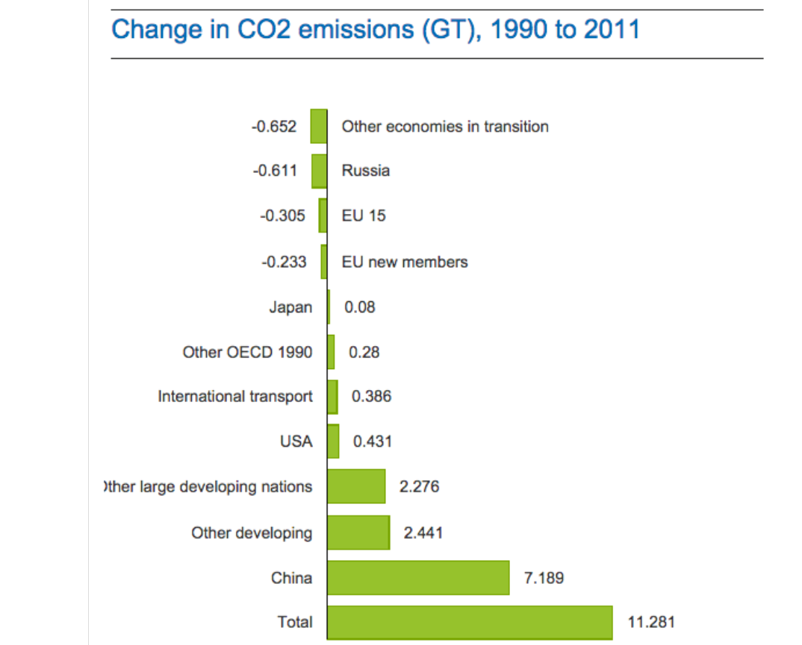

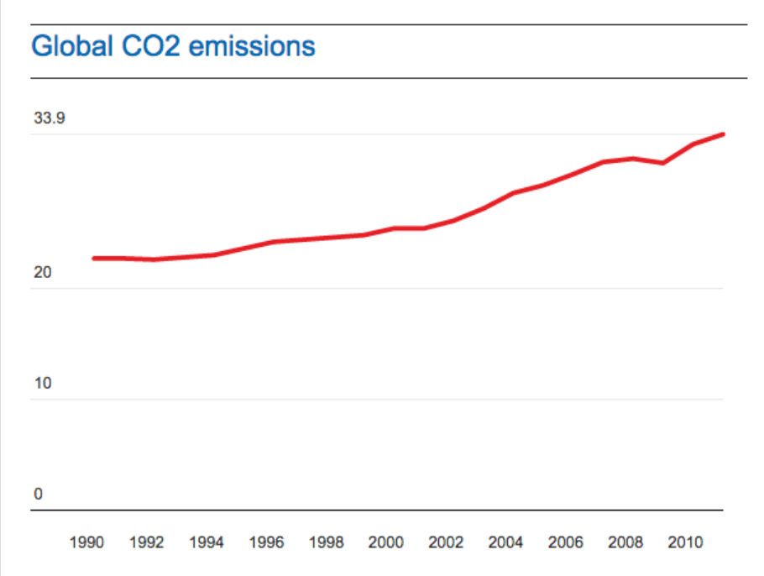
Activity 2: Assess the success of this protocol.

Describe the protocol:

Describe what it set out to achieve:

Describe what the results were:

Use adjectives (such as large, small, great or little) to assess the success of the protocol. Make sure you explain why you think this:

In order to achieve an “A” grade for this task - you will need to add in some stats and facts about the long term predictions from this podcast

https://www.gimletmedia.com/science-vs/climate-change-the-apocalypse#episode-player

Listen 21:00 mins in until 30:00

Incorporate these in order to back up your statement about the success of the protocol. In order to do this, ask yourself questions like “was the protocol put in place to stop these changes?” and “How would this podcast have been different if the goals of the protocol were met?”. Feel free to add in any other stats or thoughts you have that support your assessment of the protocol.

Climate Change
- Rising sea levels
- Rising & extreme temperatures / weather

Cause and effect
- More fires burning more often and for longer
- Changes in animal patterns / behaviour eg. butterflies
- Colour of the ocean eg. Atlantic ocean changing colour from white to blue as the ice continues to melt.
What happens next?
- Was the protocol put in place to stop these changes?
- If the protocol was successful we would not have these predictions in our future?
- What would be different if the goals of the protocol were met?

